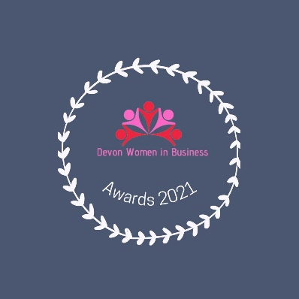

Sponsor packages

1 Overall Awards Sponsor – £500
Branding on all publicity material including social media posts, application forms, certificates, website with hyperlink, banner stand at the lunch, 5 min talk at the lunch, logo on table materials, video clip recorded.
2 Category Sponsor - £250
Branding on everything associated with their category pre-event and on the day, present award at the lunch, mentions on social media posts about their category, logo and hyperlink against category on the website.
3 Bespoke packages - from £100
E.g. programme sponsor, trophy sponsor etc.

Contact Maureen Frost of Astrality Business Services on 07717 130226 or email maureen@astralitybusinessservices.co.uk to express intertest or discuss in more detail

